**GEAR PUMP PERFORMANCE**

**DEPARTMENT OF MECHANICAL AND INDUSTRIAL ENGINEERING**

by

**NATHAN ROBINSON**

**TEAM B**

**Akshay Patel**

**Josh Gurtatowski**

**Brandon Negri**

**Nathan Robinson**

**Instructor : Samardzic Veljko**

**Teaching Assistants : Rajasekhar Tripuraneni**

**Subhajit Rakshit**

**ME405, MECHANICAL LAB-II**

**Summer 2016**



***written with passion***



**Table of Contents**

Abstract 4

Introduction 5

Theoretical principals 6

Experimental methodology 7

Analysis 10-12

Results 13-17

Conclusion 18

Nomenclature 19

References 20

**Table of Figures, Tables and Charts**

Photos taken by Josh Gurtatowski.

Fig 1; Pump over Oil Tank 7

Fig 2; Suction Gauge 7

Fig 3; Electric Motor Dial 8

Fig 4; Discharge Gauge 8

Fig 5; Thermometer 9

Fig 6; Gallon Counter 9

Table 1; Data and Conversions 1250 RPM 10

Table 2; Data and Conversions 1550 RPM 11

Table 3; Data and Conversions 1550 RPM 11

Table 4; Data and Conversions 1250 RPM 11

Table 5; Data and Conversions 1550 RPM 12

Table 6; Data and Conversions 1850 RPM 12

Chart 1; 1250 RPM Flow Rate vs Pump Head 13

Chart 2; 1550 RPM Flow Rate vs Pump Head 13

Chart 3; 1850 RPM Flow Rate vs Pump Head 14

Chart 4; 1250 RPM (Eb, Ef, Eh) vs Pump Head 14

Chart 5; 1550 RPM (Eb, Ef, Eh) vs Pump Head 15

Chart 6; 1850 RPM (Eb, Ef, Eh) vs Pump Head 15

Chart 7; Power Efficiency vs Pump Head for all speeds 16

Chart 8; Volumetric Efficiency vs Pump Head for all speeds 16

Chart 9; Flow Rate vs NPSH for all speeds 17

**Abstract**

This gear pump experiment, gives insight on the use of the gear pump itself in terms of flow capacity, oil temperature, pressure both at the discharge and suction outlet, gear rotational speed as well as the power required to run the pump.

The manual cited objective is to determine the operating characteristics of the pump at various speeds, in this the three various speeds chosen were 1250, 1500 and 1850 RPM at which the electrical motor was set to turn one of the meshed gears inside the pump casing which formed a suction pressure and start the flow of the fluid which in this case is oil instead of water because unlike the centrifugal pump, the gear pump requires very close clearance in order to minimize the volume flow rate of the fluid passing through said clearance. Various characteristics of the pump are measured while at holding the pump at previously said speeds, data is recorded and observed as the discharge and suction pressures are changed in increments of 5 psi for the discharge pressure and 2 inches of Hg for the suction pressure.

The most remarkable findings in this experiment are given by obtaining higher power efficiency and volumetric efficiency at higher speeds but showing a decreasing flow rate at higher pump head values due to the slip effect.

**Introduction**

As mentioned in the manual the gear pump is widely used in lubrication systems, so its application can be seen in various types of engines where lubrication fluid needs to be present or pumped into the system.

As previously mentioned the objective here is to determine the characteristics as well as the efficiency of the gear pump while running at various different speeds and changing the discharge and suction pressures through increment inside a preset pressure range.

First the electric motor was adjusted to a speed of 1250 RPM, all valves were opened and data was recorded on all intervals while the discharge valve was being closed 5 psi at a time. And this was repeated with speeds of 1550 and 1850.

The second part of the experiment was to do the same but this time adjusting the suction valve 2 inches of Hg at a time.

**Theoretical Principals**

**Flow Rate**

The theoretical flow rate is constant since the pump is operating in a closed system, but due to a clearance between the two parallel plates referred to as “head”, creates a reduction in flow rate referred to as “slip”. The slip can be determined by,

Q = Page 24 from Lab manual.

By subtracting this slip value from the theoretical flow rate, the actual flow rate can then be obtained.

**Pump Head**

The theoretical value for the pump head can be obtained through Bernoulli’s equation and subtracting the suction head from the discharge head.

Page 26 from Lab manual.

**Hydraulic Power**

The hydraulic power from the pump can be determined through the hydraulic break power which is the sum of the useful hydraulic power and the frictional losses which are dissipated as heat. The hydraulic power is proportional to the pump head.

Page 27 from Lab manual.

**Efficiency**

The pump power efficiency is the ratio of the hydraulic and brake power.

Page 28 from Lab manual.

**Net Positive Suction Head (NPSH)**

Page 28 from Lab manual.

**Experimental Methodology**

The system is compound of an oil tank below the gear pump as shown below.

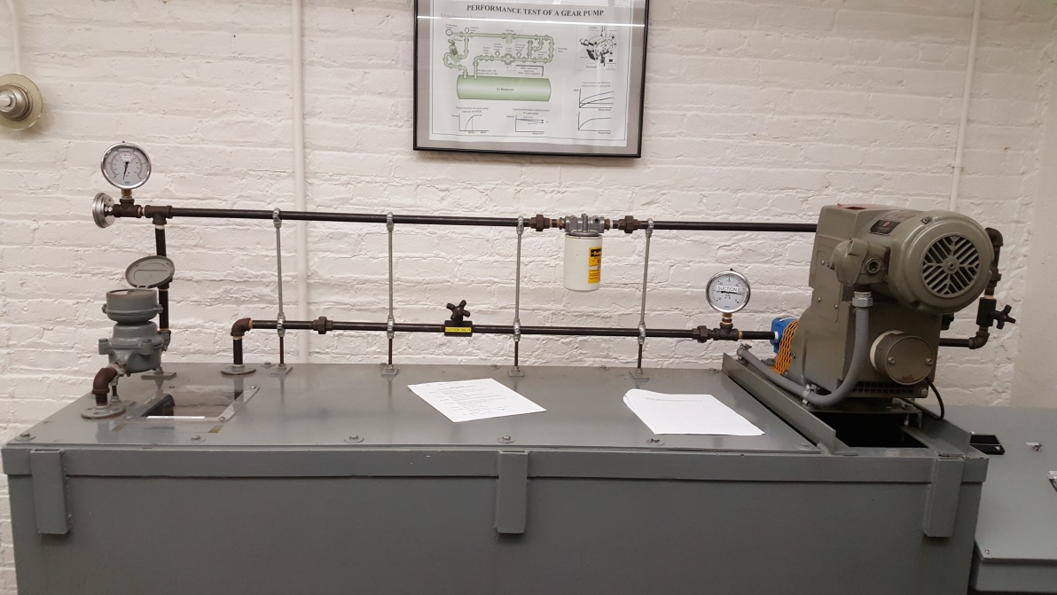

**Fig 1; Pump over Oil Tank**

The oil first passes through the suction valve and this pressure is measured by the gauge below.

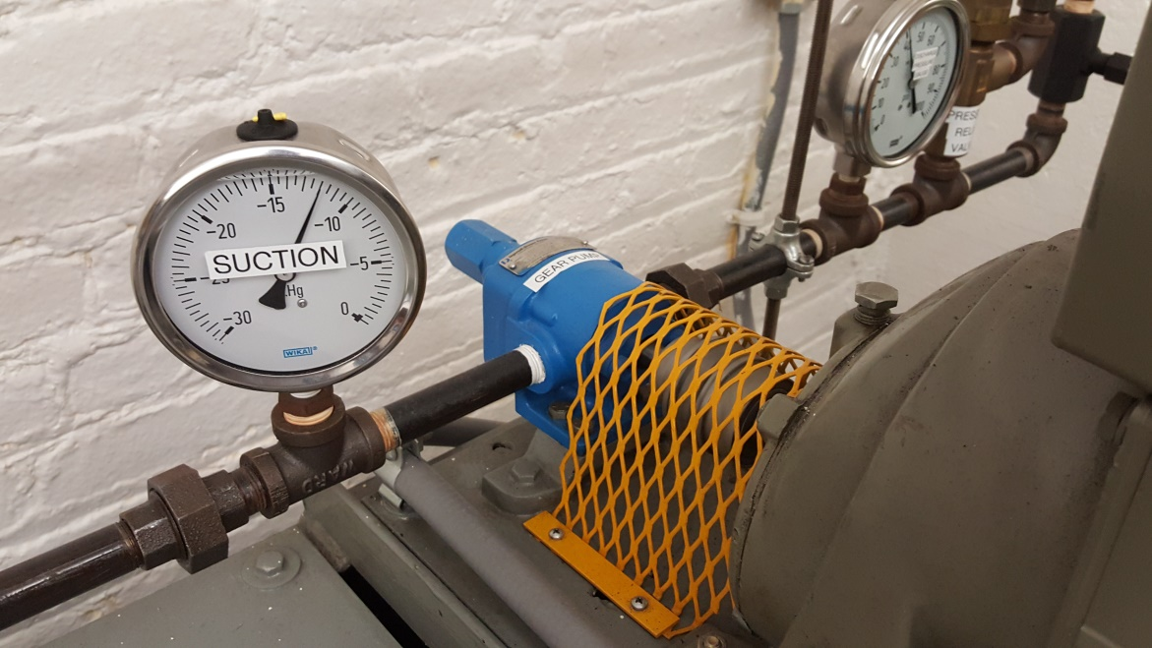

**Fig 2; Suction Gauge**

The oil then enters the pump with adjusted speed set by the electric motor dial shown below.

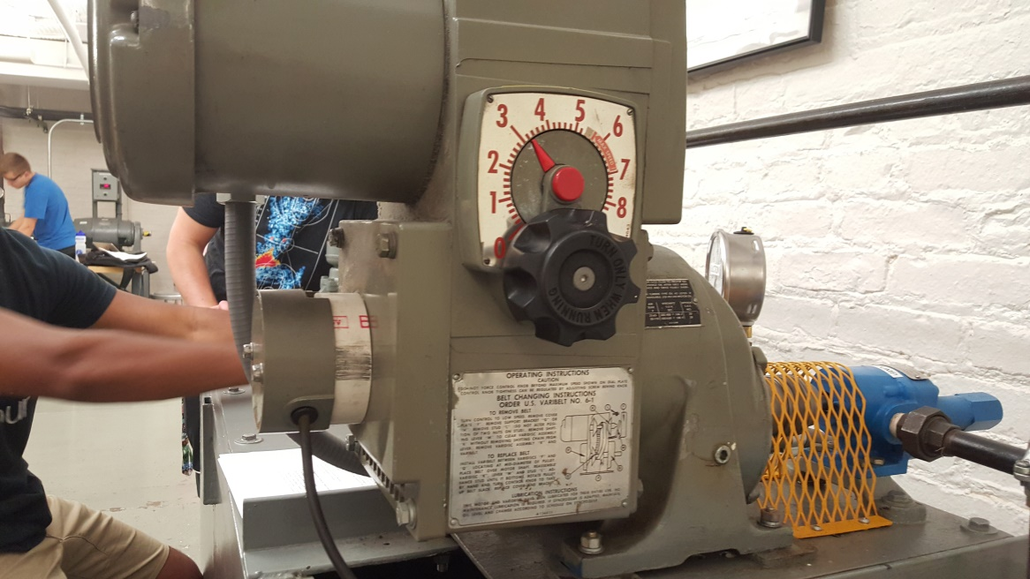

**Fig 3; Electric Motor Dial**

At the pump outlet there is the discharge valve and the gauge to measure this pressure.

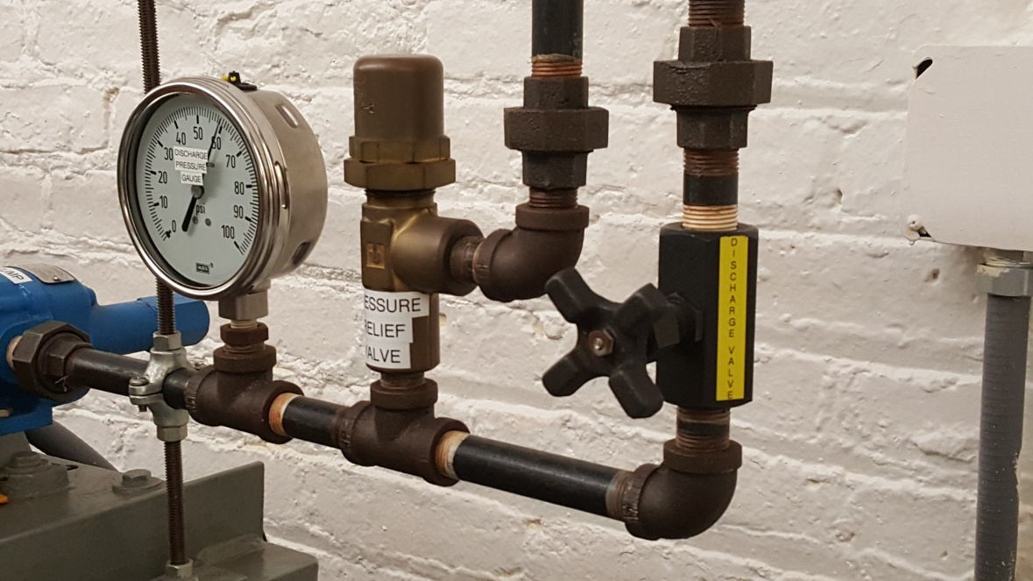

**Fig 4; Discharge Gauge**

The temperature of the oil can be recorded by the thermometer attached after the discharge valve.

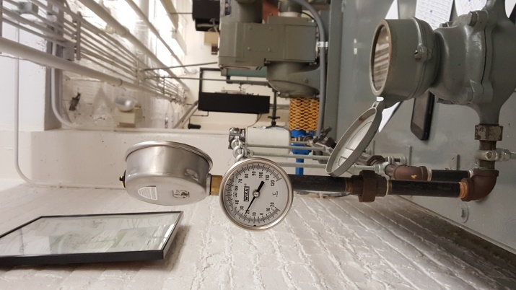

**Fig 5; Thermometer**

And finally the flow rate can be determined by the gallon meter shown below.

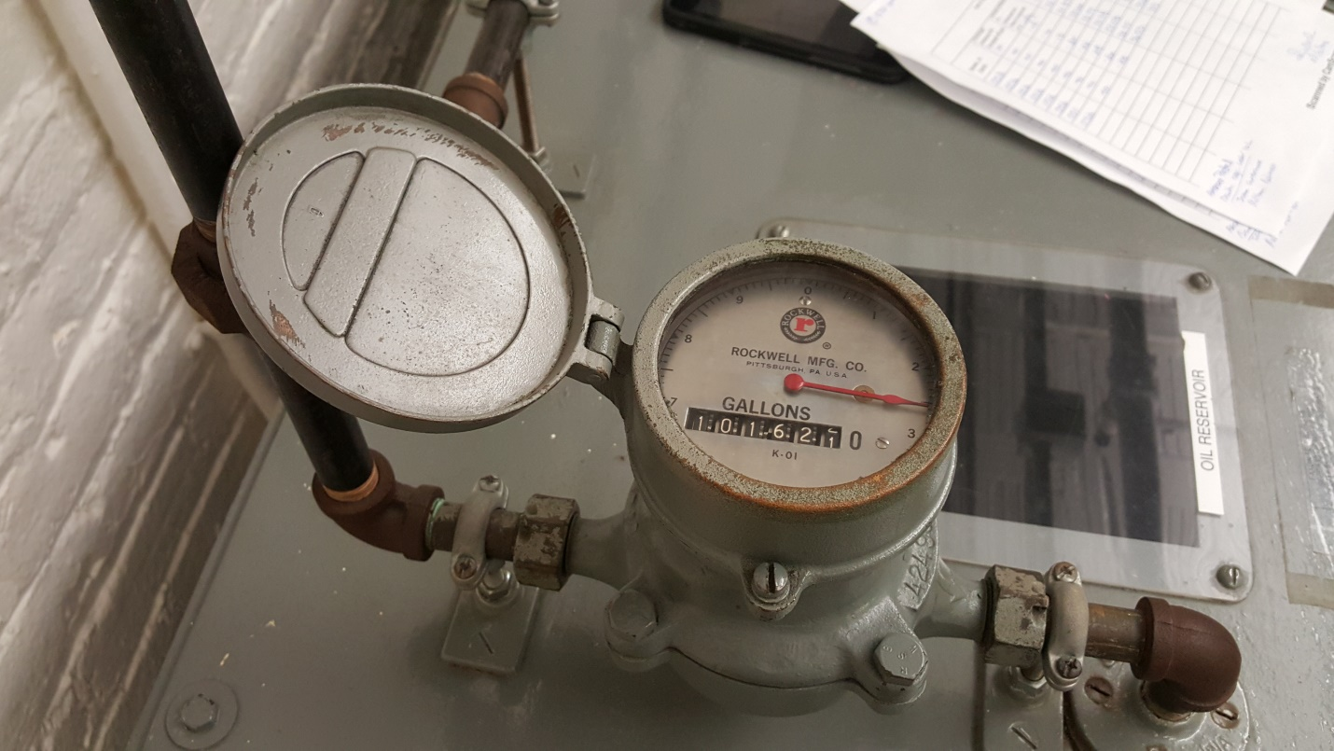

**Fig 6; Gallon Counter**

**Analysis**

Calculation for N = 1553

Ps = -14.5 in Hg 🡪 Ps = -49.103 KPa

Pd = 45 psi 🡪 Pd = 310.264 KPa

Q = 1.8 GPM 🡪 Q = 0.000113562 m3

BHP = 342 Watts 🡪 BHP = 0.4586 Hp

Cross-sectional Internal Area of Pipe= 0.000194 m2

Temp = 21 oC

Ɣ = 8632.8 N/m3

Hp = (Pd-Ps)/ Ɣ = (314.264 + 49.103)/8632.8 🡪 Hp = 42.09 m

En = Q ƔHp = (0.000113562)(8632.8)(42.09) 🡪 En = 41.2633 W

HHP = (1.341)(Q)(Pd-Ps)/1000 🡪 HHP = 0.055336 Hp

FHP = BHP – HHP 🡪 FHP = 0.40326 Hp

Ŋ = HHP/BHP X 100 🡪 Ŋ = 12.0663 %

Vs = Q/A 🡪 Vs = 0.5854 m/s

Pv = 1 mmHg 🡪 Pv = 13.33 Pa

NPSH = Ps/Ɣ + Pa/ Ɣ + Pv/ Ɣ + (Vs^2)/2g 🡪 NPSH = 6.0642 m

**Table 1; Data and Conversions 1250 RPM**



**Table 2; Data and Conversions 1550 RPM**



**Table 3; Data and Conversions 1550 RPM**



**Table 4; Data and Conversions 1250 RPM**



**Table 5; Data and Conversions 1550 RPM**



**Table 6; Data and Conversions 1850 RPM**



**Results**

As shown in the charts below, it is seen that the flow rate in the gear pump decreases as the pump head (Hp) increases, ideally the flow rate should stay constant but due to the clearance in the gear pump, some of the oil is returned to the tank, the flow rate of this oil is called slip.

**Chart 1; 1250 RPM Flow Rate vs Pump Head**

**Chart 2; 1550 RPM Flow Rate vs Pump Head**

**Chart 3; 1850 RPM Flow Rate vs Pump Head**

So it is clearly observed a higher Hp value increases the slip and this causes the actual flow rate to decrease somewhat linearly.

**Chart 4; 1250 RPM (Eb, Ef, Eh) vs Pump Head**

**Chart 5; 1550 RPM (Eb, Ef, Eh) vs Pump Head**

**Chart 6; 1850 RPM (Eb, Ef, Eh) vs Pump Head**

Ideally the friction force power would remain constant throughout the pressure variation; the data seems to withhold this statement as in some cases the readings tend randomly upward and downward most likely due to reading error variations.

The hydraulic force, being the difference of Brake force and friction force can be observed to increase along with the higher pump head value this also gives result to the efficiency behavior to increase as well observed in the chart below.

**Chart 7; Power Efficiency vs Pump Head for all speeds**

Besides observing a higher efficiency with higher pump head, it can also be observed that with higher speed comes higher power efficiency as well.

Contrary to the power efficiency, the volumetric efficiency decreases with the increase in Hp and this is shown in the chart below.

**Chart 8; Volumetric Efficiency vs Pump Head for all speeds**

The volumetric efficiency does prove to be higher at the highest speed 1850 RPM although the data shows the intermediate speed 1550 RPM to have the lowest volumetric efficiency this may be due to measurement error.

**Chart 9; Flow Rate vs NPSH for all speeds**

Although somewhat unclear due to the data range it can be observed in this chart clearly that the flow rate decrease as the net positive suction head increases and would eventually come to a critical point where the flowrate would theoretically have a negative value and this is problematic cavitation would occur and this is highly undesirable because it can damage or even destroy the pump itself.

**Conclusions**

The gear pump has shown in this experiment to have viable efficiency at high speeds, more so then low speeds, as well as being able to pump highly viscous fluids such as the oil used in this experiment due to the mechanics of how it pumps the fluid through the meshed gears. And due to the gear pump having increased efficiency at higher speeds, says that this kind of pump could very well be a viable choice in processes where the pump will be left turned on for long periods of time and maintained at a high speed thus not having to cross through the low speeds when restarting the pump and just as in automobile the oil must an elevated temperature in order to avoid damaging the gears when not fully optimized in regards to being completely lubricated which increases the friction force power thus lowering the efficiency as well.

The volumetric efficiency just as the flow rate is shown to decrease as the pump head value increases, this gives way to understand that the more fluid that is being pumped through the gears is going to create a larger clearance between the pump casing and the gears themselves thus giving the effect of some fluid being pumped back into the inlet valve as slip and the more slip there is results in less net flow rate and this results in less hydraulic force power thus giving the pump again an overall lower power efficiency than would ideally had been acquired by having no slip effect.

And as explained in the discussion segment regarding the Net Positive Suction Pressure the gear pump does have a critical limit on how flow rate it can potentially handle at a set suction pressure in order to operate without any failure due to cavitation inside the pump casing.

**Nomenclature**

Q – Flow Rate

RPM – Revolutions Per Second

Vs – Suction Velocity

Ps – Suction Pressure

Pd – Discharge Pressure

⧍P – Pressure Difference

Hp – Pump Head

Eh – Hydraulic Power

Eb – Brake Power

Ef – Friction Force Power

Ŋ – Efficiency

HHP – Hydraulic Horse Power

BHP- Brake Horse Power

NPSH – Net Positive Suction Head

Vol.ƞ - Volumetric Efficiency

**References**

ME 405 Laboratory Manual Harnoy. New Jersey Institute of Technology